SUMMER 2014
First Holy Communion:
7 children made their First Holy Communion this year on Sunday, 1st June. Congratulations to them all.

Confirmation:
13 children from 5th and 6th classes made their Confirmation on Sunday, 11th May. Congratulations to them all.

Irish Pride Competition:
Children entered a poem for the Irish Pride Competition in the Primary Planet magazine.

School Tour:
The school tour was on Friday, 16th May in Adventure World, Limerick. There were water, novelty and land activities during the day. It was a great success.

RSE Talk:
The 5th and 6th class children had a RSE talk on Tuesday, 27th May.

Sports Day:
We held our Sports Day on Wednesday, 18th June. There were many novelty races. Everyone enjoyed the day; even the teachers who took part!! The children got a certificate and gold medal for their participation.

Inspector Visit:
The Inspector paid us an unexpected visit in May and was very happy with every aspect of the school.
Sports:
Thanks to Ms Watson for Gaelic Football training and to Kevin Molloy for the Hurling training throughout the year.

Down Syndrome Ireland:
We sold Ice-cream during our Sports Day and raised €121 for Down Syndrome Ireland. Well done.

New Junior Infants:
The new Junior Infants visited the school on Friday 20th June with their parents and met the teachers and children in the Junior Room.

Graduation Mass:
The 6th class children had their graduation mass on Thursday 19th June. It was a very special occasion. We wish them all every success in the future.

Sports Equipment:
The school got a new basketball set, hurdles, tag rugby kit, javelins and other sports equipment.
Ms Watson completed a course in the School of Badminton and is training the children in it.

Portumna Castle 21st Birthday Competition:
Congratulations to Ciara Gallagher and Ava Downey O’Mahoney who won 1st Prize in this competition and Calum Birtwistle and Colleen Heagney who were Runners Up. Well done to all who took part.

School Garden:
Tess and the children painted the wall at the school garden. It is looking really nice with the new plants and garden bench.

Raising of Flags:
We celebrated the raising of our Green and Blue Flags on Tuesday 24th June. Daniel Hynes and Tara Madden raised the Green Flag and Ronan Fahy and Simon Madden raised the European Flag. It was as great day for all. There were bouncy castles for the children and photos were taken for the Connacht Tribune.

Super Summer Fair Art Competition:
The children have also entered the Super Summer Fair Art Competition which is run by the Chamber of Commerce Portumna for the Super Summer Fair which is taking part during the weekend.

Swimming:
The children from 1st - 6th classes will be starting their swimming lessons on Thursday 11th September and finishing on Thursday 23rd October. We will give you more details when the school re-opens.

New School Uniform:
The school has a new school uniform and is compulsory for the new Junior Infants.

Summer Holidays:
The school re-opens Friday, 29th August after the summer break.

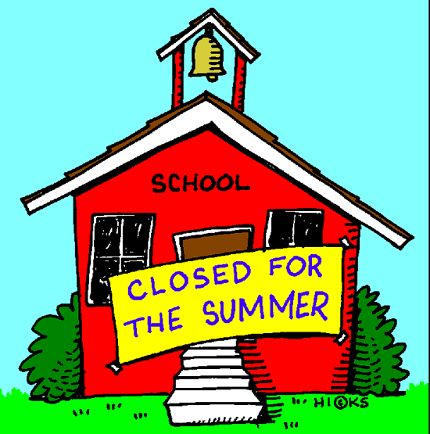

We hope you & your families
have an enjoyable summer break
from all in
Scoil Mhuire N.S. Gortanumera
